|  |  |
| --- | --- |
| TASK MANAGER WEBSITE  -Gaurang Srivastava (BT23ECE088) Aditi Chandak (BT23ECE095) | TITLE  A Simple and user-friendly Task Manager Website where you can handle your tasks by creating a profile and then you can keep track of your tasks and can work in a more efficient and structured manner.  Gaurang Srivastava |

INTRO PAGE

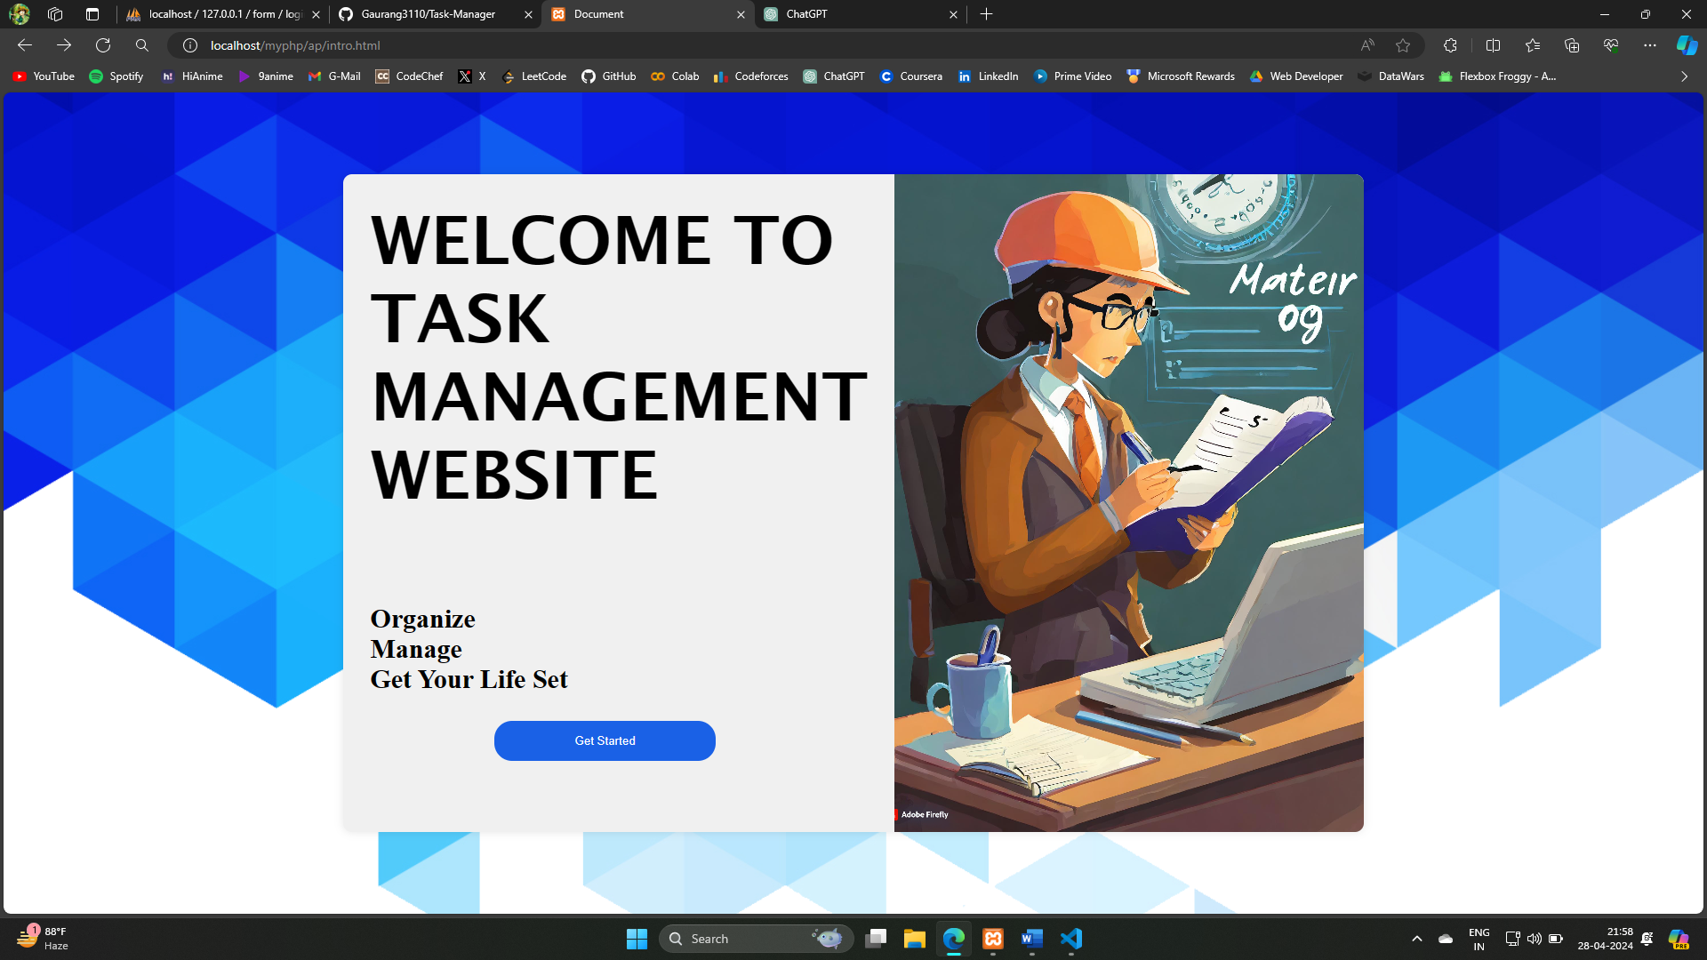

Login Page –

If Submitted NULL-

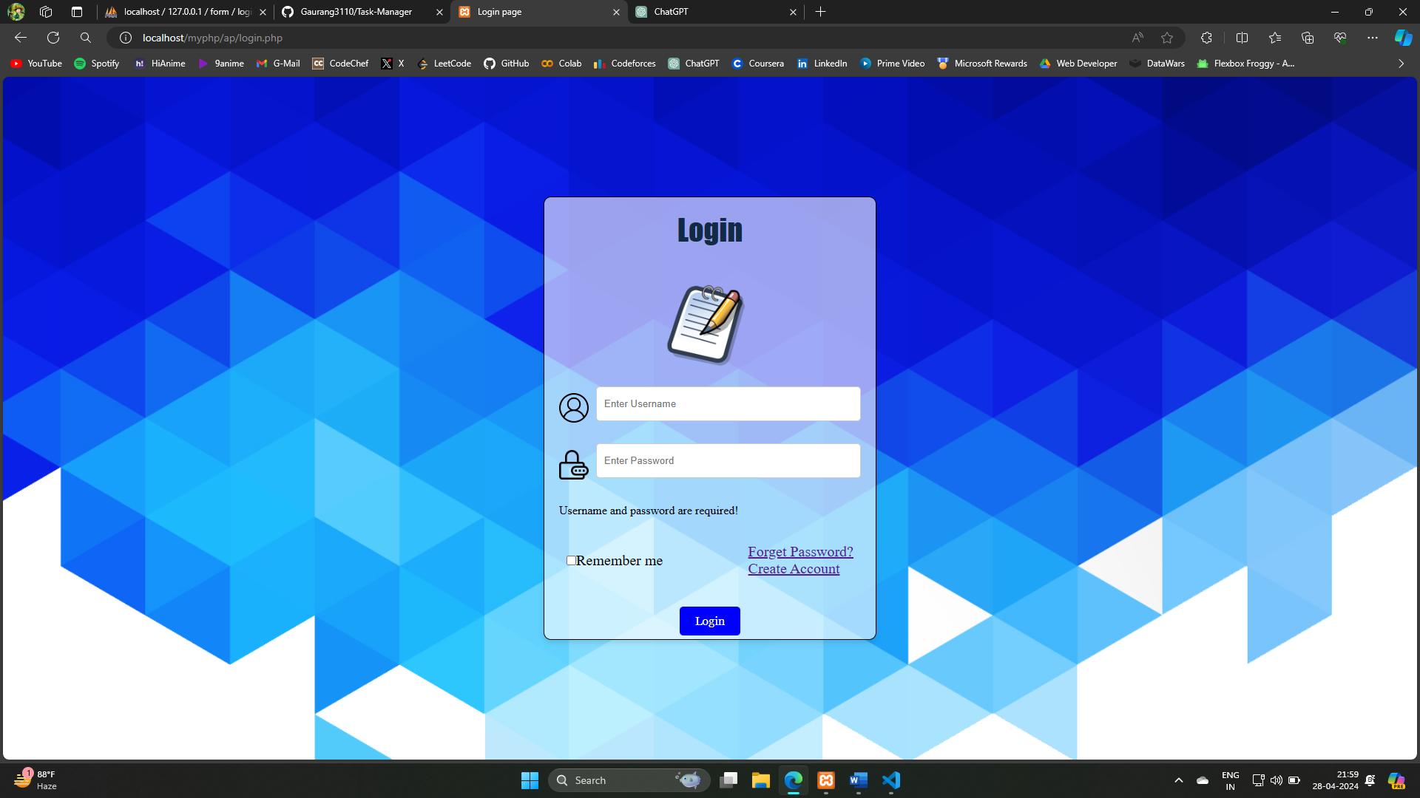

If Submitted with wrong USERNAME-PASSWORD

FORGET PASSWORD –

CREATE ACCOUNT

If Submitted NULL

If Account Created-

HOME PAGE –

TASK ADDER –

PROFILE –

LOGOUT –

CONTACT US –

FAQS –

FEEDBACK-

SQL DATABASE –

(Manages your Username and Password)

